# Progress within the OSLC Product workgroup

This short document summarises the aim of the group, work done, a first view of potential scenarios that could inform a first target scenario and potential workshare.

Thanks to all of those who have contributed inputs and furthered the lively productive discussions.

## Contents

Problem summary

Motivating summary and draft value proposition

Topics of interest

What has happened so far including inputs received

Scenarios

Suggested work share

## Problem summary

Complex engineered products and systems rely upon a large variety of information, coherency is very difficult to achieve, affecting product quality, safety and success.

## Motivation

Today OSLC is the most proven and open standard for creating a Digital Thread of engineering information to enable coherency across distributed sources and usages

The aim here is to extend OSLC to enable more applications to play a peer level role in an enterprise Product structure management (EBOM – hierarchical assembly of components that represents the physical product) setting to close major gaps in the Digital Thread

Examples areas are to enable representation of structure and relationships between system, software and hardware product information and other information; such as to reflect changes to an EBOM, its versioned managed artefacts and how it changes over time.

## What can be the value proposition ?

Allows customers to move ahead with open Digital Threads that should be more durable and so help them reduce cost, time and errors in managing overall information coherence. This is expected to enable further advantage of speeding up exploitation of information towards business initiatives.

## What topics are of interest to the community ?

To achieve an engineering centric Digital Thread, critical topics are

Isolation of use cases for defining product structure, configuration management, version management, linking, product variant management

* A new OSLC Product Domain for representation of Product resources including their composition
* New predicates for linking between existing OSLC resources and Product resources and the addition of properties for link validity
* Alignment across existing OSLC Change and Configuration management schemes and those in use in OSLC
* Extension of data and process coverage to wider product application concerns by extended vocabularies

Way of working

We have identified certain aims that can help us focus and collaborate:

* + Aim to represent and bridge to more of the PLM domain
  + Aim for a “Sufficient core” and a means of extension for Product domain
    - And aim to do more than the default approach in Architecture Management
  + Clarify the scope of changes for Configuration Management

## What has happened so far ?

An informal OSLC Product Workgroup received submissions from Sodius-Willert, IBM, PTC, Saab, Bosch, Raytheon and others and discussed experience, needs and approaches.

Presentations are available at <https://github.com/oslc-op/Product-Definition>

Four main areas of product information were identified

coding & classification – assisting identification of products, their properties and associated meta-data for instance to tailor business processes (e.g. lifecycle states)

structure – assisting aspects of aggregation or nominal construction of products, families from products, products from sub-products and components and so on up and down – with greater or lesser aggregation

change & configuration – assisting identification and achievement of resolution of structure or information content such as by lifecycle state at a given stage of evolution or usage

associated information – assisting identification and control of related information such as in the disciplines

Each of these will need further scoping and prioritisation – this process is being led by vendor and OEM inputs.

Certain findings are:

* Strong support for a distinct OSLC Product resource – e.g. PTC, SoWi, Bosch, Saab
* Interest to clarify “product” and OSLC configurations – PTC
  + to support a Configured Item CI concept – Bosch
  + to support combine baselines - Raytheon
* Need to clarify the view concept cf OSLC Configuration Selections - Saab
* Interest in Classification – Bosch
  + and inheritance
* Need to represent product state and change of state – Bosch
* Need to clarify use of types of versioned resources – Bosch, PTC
  + - concept + Context

explicit revisions and latest

* Need a specific link between Requirements and products – Bosch

## What business scenarios are being considered ?

Discussion has revealed scenarios such as

Create traceability between Requirements and a Product

Create associations between Product Change Requests and changes request in the disciplines

Bosch provided a list which has received most discussion on the 1st topic

* Product Master Data < which relates to defining Product structure and properties
* Classification management < relates to Product structure and properties
* Product line Eng. < relates to Product structure and properties working with Configuration Mgmnt
* Configuration Data < relates to Configuration Mgmnt
* Link index < relates to linking
* Link validity < relates to linking
* Change Set Delivery < relates to Change and Configuration Mgmnt

From current input 3 scenarios have been summarised here with potential use cases, and then aligned to the Bosch examples

1. Creation of products (Product Master Data scenario) involving structure and meta-data properties

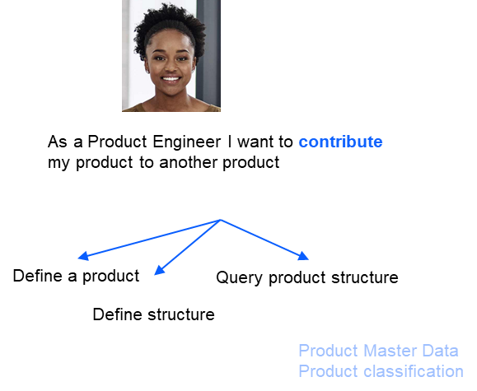

Contribute means provide either as a stand alone product or as a contribution to some product structure.

1. Linking between products and other engineering information (Linking scenario) beginning with Requirements

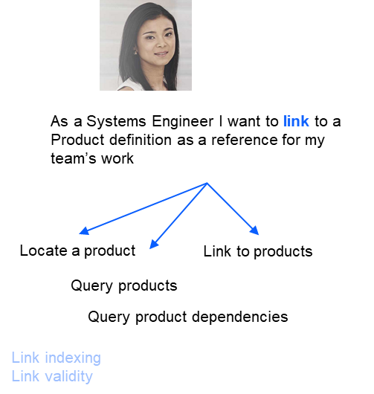

This could be link to or link from depending on what info exists already and needs to account for prevailing “upstream” and “downstream” conventions that OSLC has.

1. Change and configuration management of products and their related information (Configuration Management scenario)

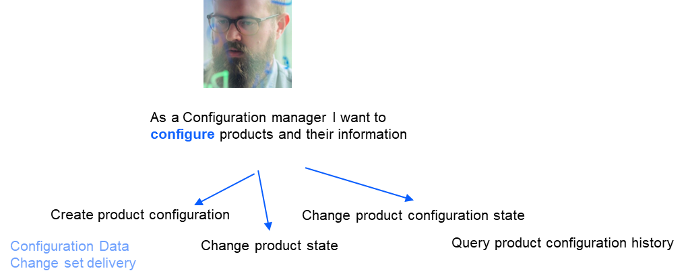

In OSLC, Configuration Management is a separate concern to both artefact structure and version identity. The aim is to preserve that but some specific coupling may be required or some practice over query support may be required.

## What OSLC specification proposals have been received ?

To define a specific product resource with properties and relationships to classify products and specify composition

To extend the current OSLC configuration management Contribution resource with properties to carry Configured Item meta-data

## Reminder of OSLC’s open world assumption

Product information is amongst the richest and most varied in the enterprise and eco-system landscape. Companies often have very elaborate product information schemes to meet many business needs, despite this, new needs arise frequently. In general there a strong relation between a organisations’ product & service innovation and new information needs.

OSLC has always aimed to adopt a minimal approach but to emphasise the open world nature of RDF, this means that servers can freely add additional data that consumers can enjoy – the only proviso is that servers must meet the cardinality of the OSLC specification and that consumers will ultimately need to decide if they look for and take other server supplied data as precedent over the OSLC properties, relationships and semantics. There is no mechanism for a consumer to either turn data on/off or change its representation other than certain media types in OSLC.

## What areas need to be worked in detail to make progress ?

* Decide on relatively few new types – for products and sub-typing of configurations
* Identify a minimum set of properties and a means to extend by discovery for classification and state
* Clarification of concepts, usage and proposals to cover the use of version marking and resolution for products in PLM compared with OSLC resources
* Property inheritance in product resource structures
* Initial or simplified approach to variant configuration specification and common usage of OSLC Configuration, Contribution and Selections plus specific properties

## What adjacent areas need some consideration as to whether they can be postponed at this stage ?

* Alignment with SysML concepts
* State change automation
* Detailed alignment with other standards – STEP 242, 239

## What could be the OSLC community outcome ?

1. A product definition specification
   1. Resource types
   2. Small set of common properties including linktypes for product structure and with common AM, RM, QM & CM domain resources
      1. Concomitant changes may be needs to other specs depending on link convention chosen
   3. Recommended practices
      1. Application of Configuration Management for PLM purposes
      2. Vocabulary extension method
2. Extensions to OSLC Configuration management resources
   1. Sub-typing
   2. Indicator of revision or latest
   3. A means of specifying a variant expression for a Selections resource
      1. Again with a means to extend
3. Extensions to other OSLC domains
   1. Originating linktypes
   2. Option of explicit artefact version identification
4. A Lyo or similar demonstrator
   1. Lyo designer could support synthesis of a Product Domain extension
   2. A configuration management Lyo or other variant would be needed

## How to organise the work ?

A specific small workgroup should prepare a Product domain specification draft which is then reviewed and refined with interested parties in the main PGB “Thursday” call.

The configuration management and discovery topics should be taken in the Thursday call once a basic draft Product domain spec is produced so that it can assist separation of concerns over products and configurations.

Gray Bachelor

20/3/22

V0.4

## Backup

What might we discuss at the OSLC workgroup

1. What can be some basic scenarios
   1. Query a product and store a reference < prefer b
   2. Link to a Product revision
      1. no config context
      2. in a config context
   3. Contribute a product to a structure
      1. Include a product in a structure
   4. Configure products and their information
      1. Create a configuration of products (and their information
      2. Change (the state of) a configuration of products (and their information
2. What product concepts to support ?
   1. Representation
      1. Multiple or single type ?
      2. Prescribed properties
         1. Classification
         2. Purpose or Usage
         3. Pedigree
      3. If multiple – what relationship properties between them
   2. Product Structure
      1. Concepts of membership are available in dcterms
      2. Concept of composition or constituency
      3. Concept of hierarchy
      4. Conditionality
   3. Information structure
      1. Related items – documents, artefacts
      2. Relationship properties
      3. Conditionality
   4. History
3. Can the OSLC orthogonal configuration concept be maintained ?